OOPS LAB

Experiment -3

NAME- ANMOL YADAV SAP ID- 500083814 ROLLNO- R214220178

**Question: 1**

1. Write a program to accept three digits (i.e. 0 - 9) and print all its possible combinations.

(For example if the three digits are 1, 2, 3 than all possible combinations are : 123, 132,

213, 231, 312, 321.)

**Code:**

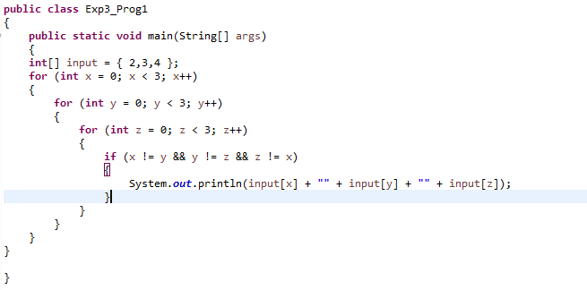

**Output:**

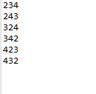

**Question: 2**

Write a Java Program to accept 10 numbers in an array and compute the square of each number. Print the sum of these numbers.

**Code:**

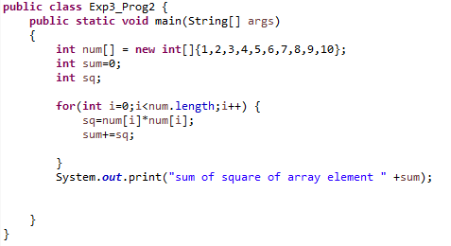

**Output:-**

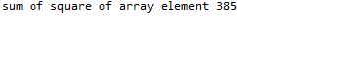

**Question: 3**

Write a program to input a number of a month (1 - 12) and print its equivalent name of the month.(e.g 1 to Jan, 2 to Feb. 12 to Dec.)

**Code:**

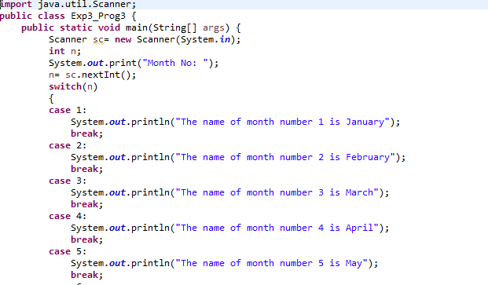

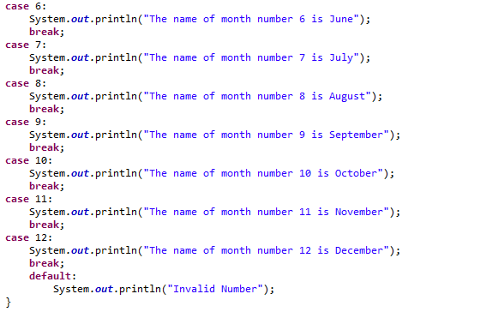

**Output:-**

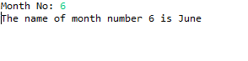

**Question: 4**

Write a program to find the sum of all integers greater than 40 and less than 250 that are divisible by 5.

**Code:-**

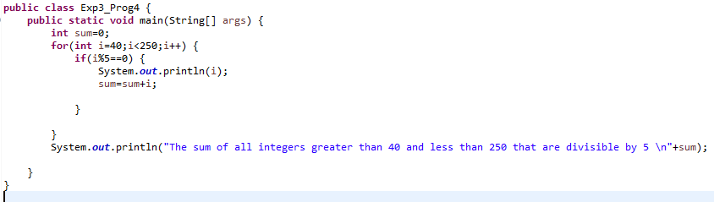

**Output:-**

